Plane in Solid Geometry

Definition
# Source: AI Source: Provided by: [Data Path: Persons Table -> ID Column: 1, Name_En Column: Motasem Essam] -> From: [ChatGPT] on [7/25/2026]
A Plane in Solid Geometry is a flat, two-dimensional surface that extends infinitely in every direction within its space. It has length and width but no thickness.
A plane can contain points, lines, and geometric figures, and it can intersect other planes and three-dimensional solids.

Simple Definition
# Source: AI Source: Provided by: [Data Path: Persons Table -> ID Column: 1, Name_En Column: Motasem Essam] -> From: [ChatGPT] on [7/25/2026]
A plane is a perfectly flat surface that continues infinitely in all directions.
Examples of finite objects that help us visualize a plane include a tabletop, a sheet of paper, or one face of a cube. However, a mathematical plane has no boundaries.
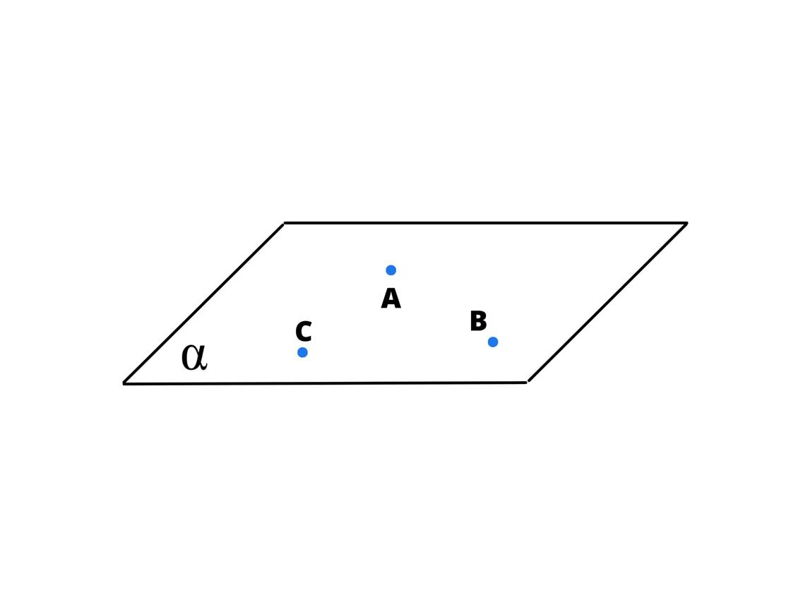
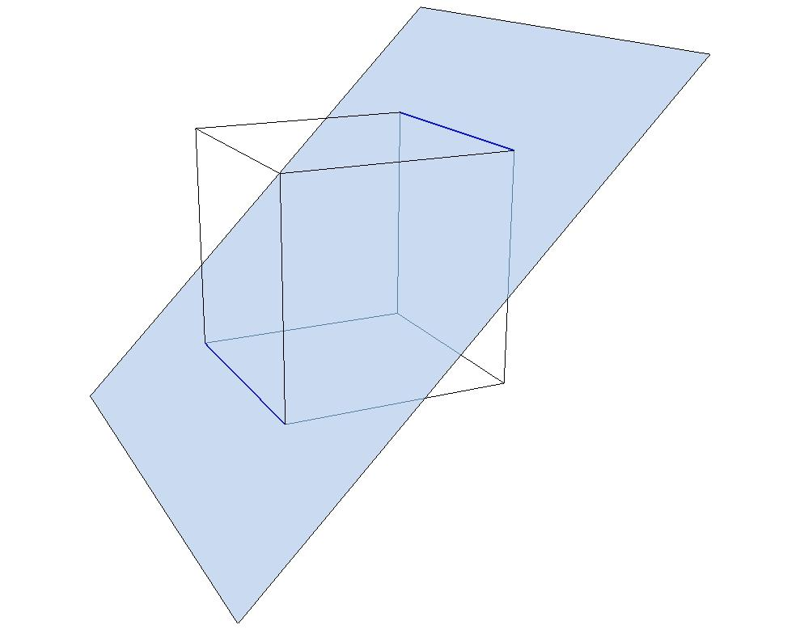
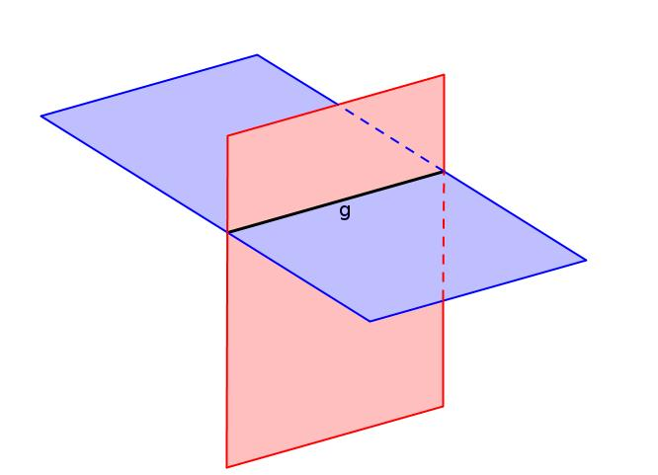

Fundamental Properties
# Source: AI Source: Provided by: [Data Path: Persons Table -> ID Column: 1, Name_En Column: Motasem Essam] -> From: [ChatGPT] on [7/25/2026]
- Two-Dimensional: A plane has length and width but no thickness.
- Infinite Extent: A mathematical plane extends without boundaries in every direction within the plane.
- Flatness: Every straight line joining two points in a plane lies entirely within that plane.
- Contains Points and Lines: A plane can contain infinitely many points and infinitely many lines.
- Defined by Three Non-Collinear Points: Exactly one plane passes through any three non-collinear points in Euclidean space.
- Separates Space: A plane divides three-dimensional space into two half-spaces.

Main Types of Planes in Solid Geometry
# Source: AI Source: Provided by: [Data Path: Persons Table -> ID Column: 1, Name_En Column: Motasem Essam] -> From: [ChatGPT] on [7/25/2026]
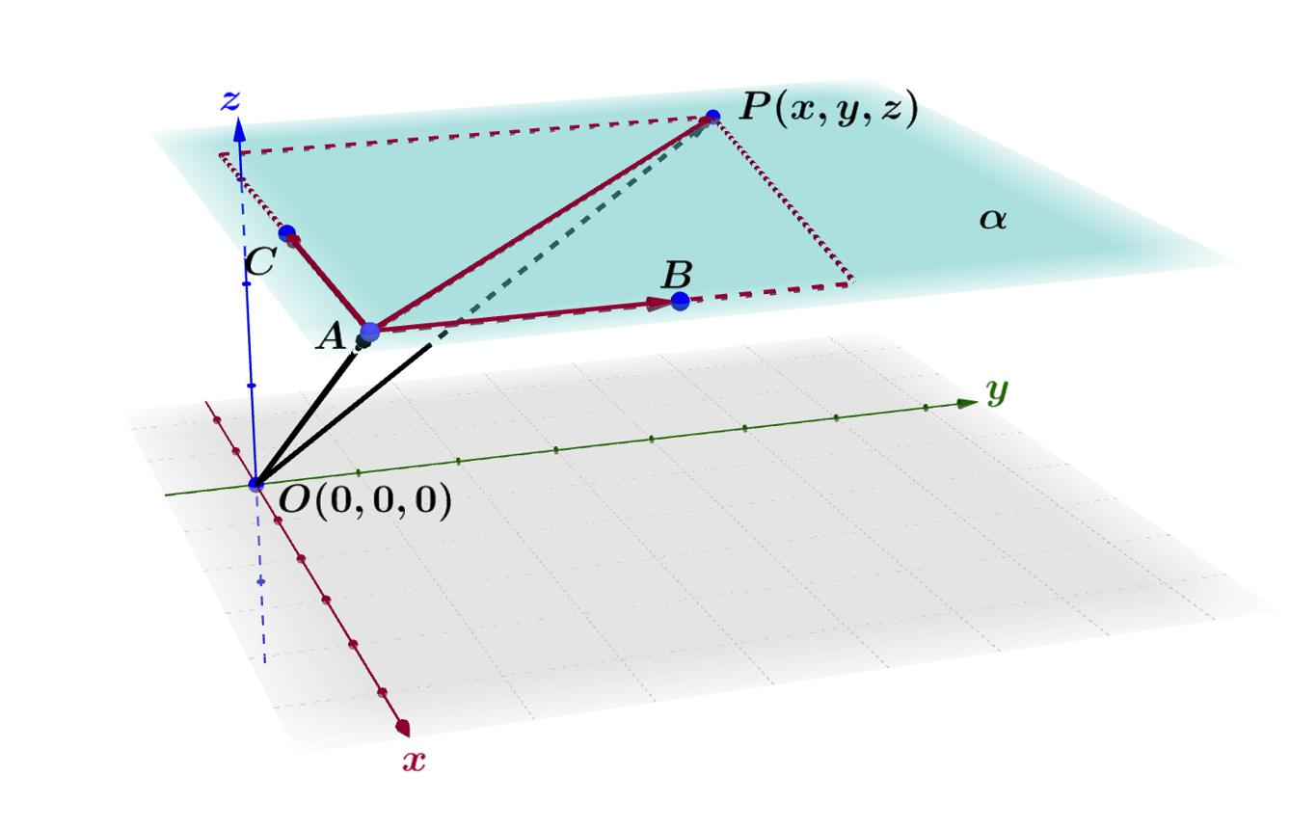
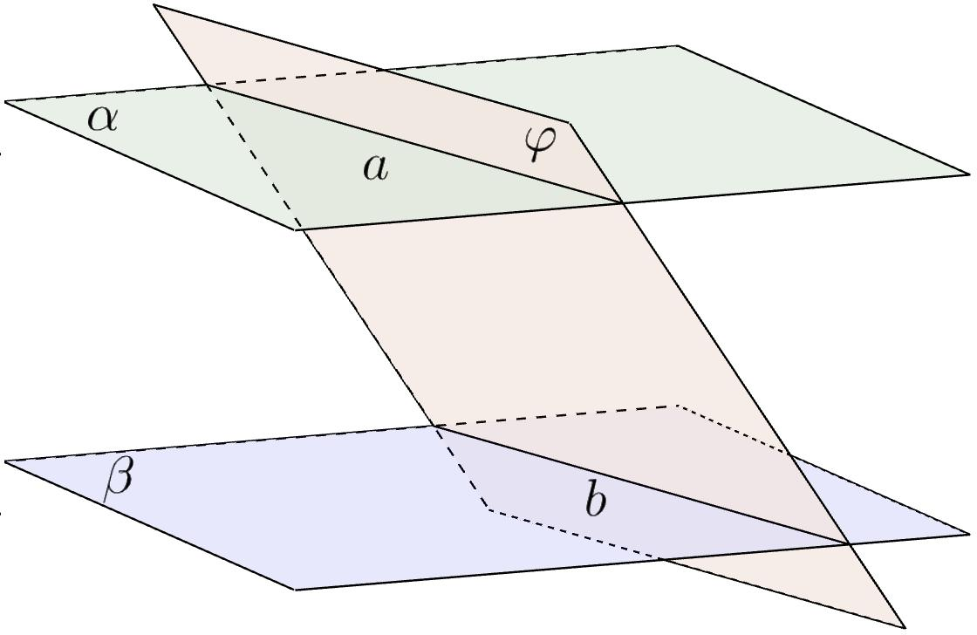
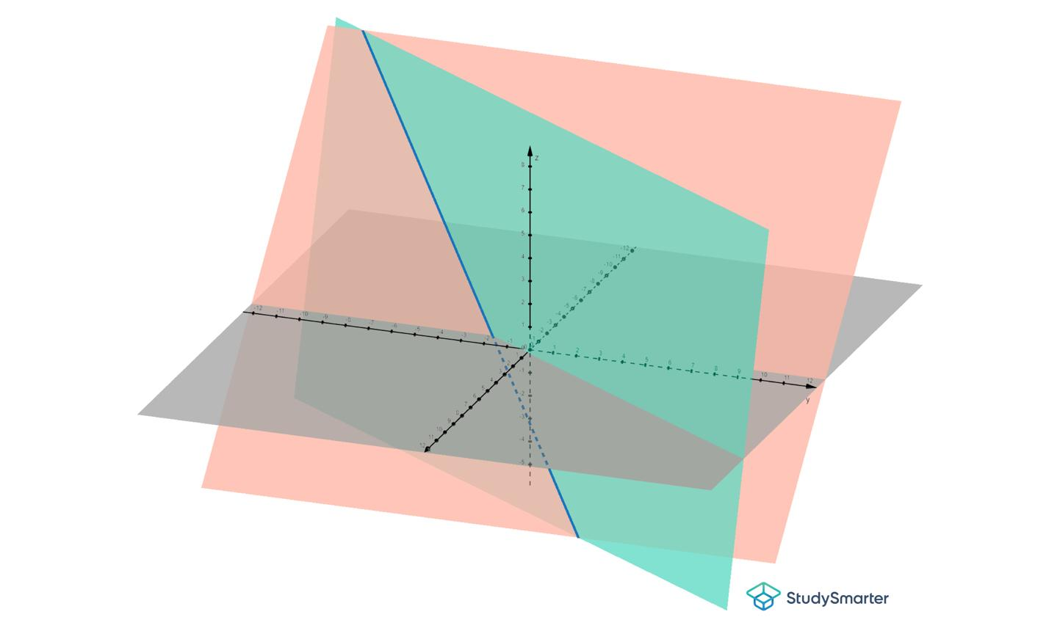
8

1. Plane in Space
# Source: AI Source: Provided by: [Data Path: Persons Table -> ID Column: 1, Name_En Column: Motasem Essam] -> From: [ChatGPT] on [7/25/2026]
A plane in space is an infinite, flat, two-dimensional surface embedded in three-dimensional space.

2. Parallel Planes
# Source: AI Source: Provided by: [Data Path: Persons Table -> ID Column: 1, Name_En Column: Motasem Essam] -> From: [ChatGPT] on [7/25/2026]
Two distinct planes are parallel if they never intersect, regardless of how far they extend.
Example: The top and bottom faces of a cube lie in parallel planes.

3. Intersecting Planes
# Source: AI Source: Provided by: [Data Path: Persons Table -> ID Column: 1, Name_En Column: Motasem Essam] -> From: [ChatGPT] on [7/25/2026]
Two distinct planes intersect along a straight line.
Example: Two adjacent faces of a cube lie in intersecting planes.

4. Perpendicular Planes
# Source: AI Source: Provided by: [Data Path: Persons Table -> ID Column: 1, Name_En Column: Motasem Essam] -> From: [ChatGPT] on [7/25/2026]
Two planes are perpendicular when they intersect at a right angle, measured between their normal vectors.
Example: Two adjacent faces of a cube lie in perpendicular planes.

5. Coincident Planes
# Source: AI Source: Provided by: [Data Path: Persons Table -> ID Column: 1, Name_En Column: Motasem Essam] -> From: [ChatGPT] on [7/25/2026]
Two planes are coincident when they occupy exactly the same plane and share every point.

How Is a Plane Defined?
# Source: AI Source: Provided by: [Data Path: Persons Table -> ID Column: 1, Name_En Column: Motasem Essam] -> From: [ChatGPT] on [7/25/2026]
A plane can be uniquely determined in several ways.
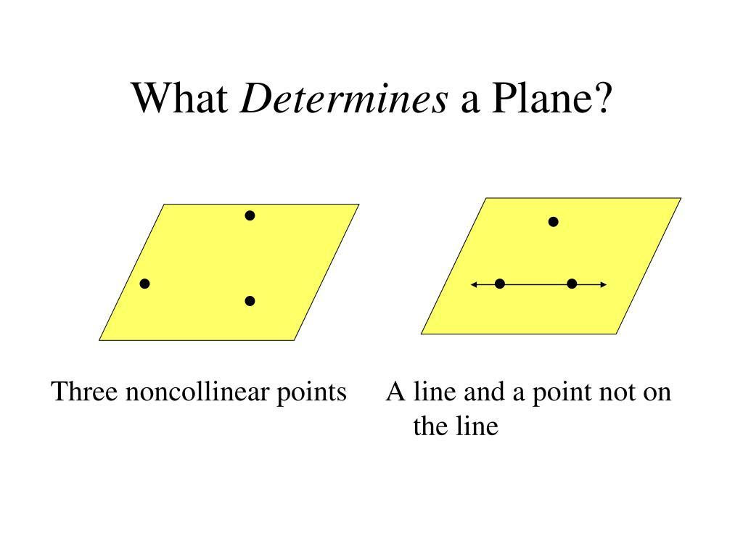
8
- Three non-collinear points: Three points that do not lie on the same straight line determine exactly one plane.
- A line and a point outside it: A line and a point not on that line determine exactly one plane.
- Two intersecting lines: Two distinct intersecting lines determine exactly one plane.
- Two distinct parallel lines: Two parallel lines determine exactly one plane.
Three collinear points alone do not determine a unique plane because infinitely many planes can contain the same line.

Representation of a Plane in Three-Dimensional Coordinates
# Source: AI Source: Provided by: [Data Path: Persons Table -> ID Column: 1, Name_En Column: Motasem Essam] -> From: [ChatGPT] on [7/25/2026]
In Cartesian coordinates, a plane can be represented by the equation
$$\boxed{ax+by+cz=d}$$
where:
- $x,y,z$ are the coordinates of any point on the plane.
- $a,b,c$ are constants defining the plane's normal direction.
- $d$ is a constant determining its position.
- At least one of $a,b,c$ must be nonzero.
The vector
$$n=\left(a,b,c\right)$$
is called the normal vector of the plane. It is perpendicular to the plane.
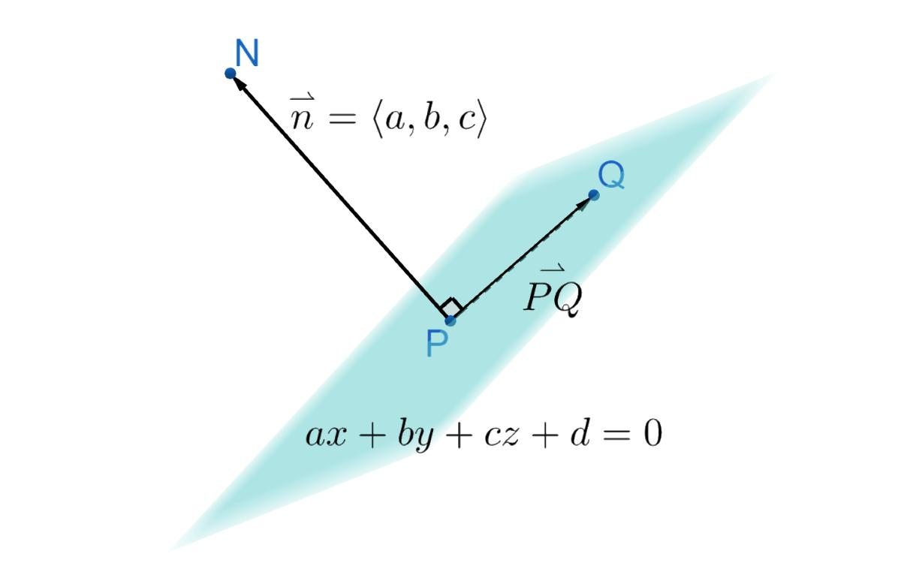
Example
Consider the plane
$$2x+y+z=6$$
The point $P=\left(1,2,2\right)$ lies on this plane because
$$2\left(1\right)+2+2=6$$
Its normal vector is
$$n=\left(2,1,1\right)$$
Any point satisfying the plane equation belongs to this plane.

Relationships Between a Plane and Other Geometric Objects
# Source: AI Source: Provided by: [Data Path: Persons Table -> ID Column: 1, Name_En Column: Motasem Essam] -> From: [ChatGPT] on [7/25/2026]
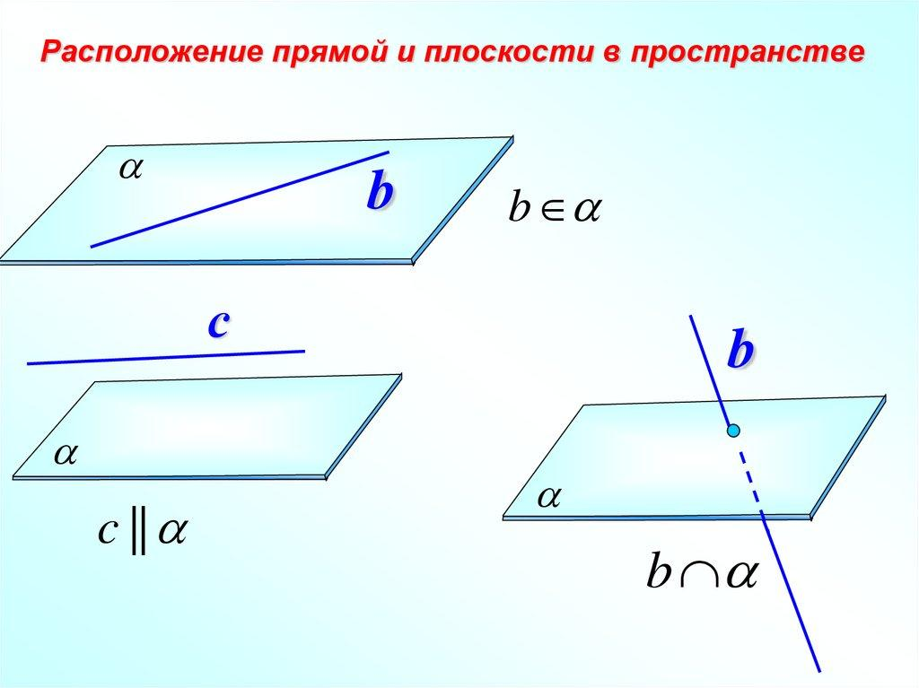
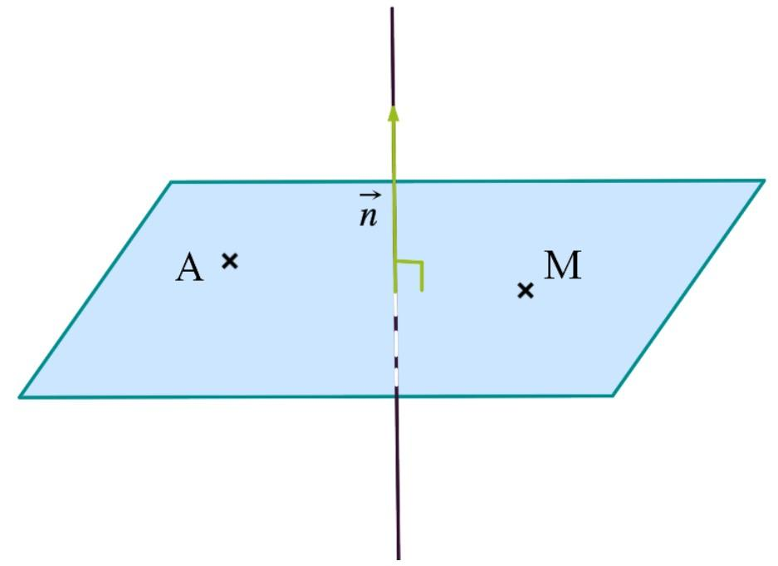
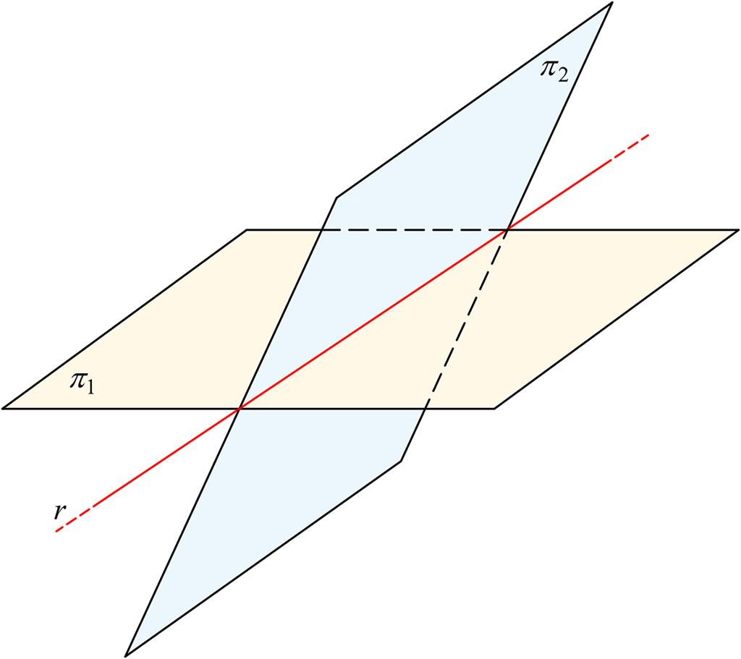

1 Plane and Point
# Source: AI Source: Provided by: [Data Path: Persons Table -> ID Column: 1, Name_En Column: Motasem Essam] -> From: [ChatGPT] on [7/25/2026]
A point either lies on a plane or does not lie on it.
For a plane $ax+by+cz=d$, substitute the point's coordinates into the equation. If the equality holds, the point lies on the plane.

2 Plane and Line
# Source: AI Source: Provided by: [Data Path: Persons Table -> ID Column: 1, Name_En Column: Motasem Essam] -> From: [ChatGPT] on [7/25/2026]
A line and a plane can have three relationships:
- The line lies entirely within the plane.
- The line intersects the plane at exactly one point.
- The line is parallel to the plane and does not intersect it.

3. Plane and Plane
# Source: AI Source: Provided by: [Data Path: Persons Table -> ID Column: 1, Name_En Column: Motasem Essam] -> From: [ChatGPT] on [7/25/2026]
Two planes in three-dimensional Euclidean space can be:
- Parallel and distinct.
- Intersecting along a line.
- Coincident.

4 Plane and Solid
# Source: AI Source: Provided by: [Data Path: Persons Table -> ID Column: 1, Name_En Column: Motasem Essam] -> From: [ChatGPT] on [7/25/2026]
A plane can intersect a solid and create a cross-section. The resulting two-dimensional shape depends on the solid and the orientation of the plane.

Important Theorems and Properties
# Source: AI Source: Provided by: [Data Path: Persons Table -> ID Column: 1, Name_En Column: Motasem Essam] -> From: [ChatGPT] on [7/25/2026]
- Three-Point Plane Theorem: Three non-collinear points determine exactly one plane.
- Intersecting-Planes Property: Two distinct intersecting planes meet along a straight line.
- Parallel-Planes Property: Two distinct parallel planes never intersect.
- Line-in-Plane Property: If two distinct points of a line lie in a plane, the entire line lies in that plane.
- Perpendicular-Line Property: A line perpendicular to a plane is parallel to that plane's normal vector.

Plane vs. Line vs. Solid
# Source: AI Source: Provided by: [Data Path: Persons Table -> ID Column: 1, Name_En Column: Motasem Essam] -> From: [ChatGPT] on [7/25/2026]
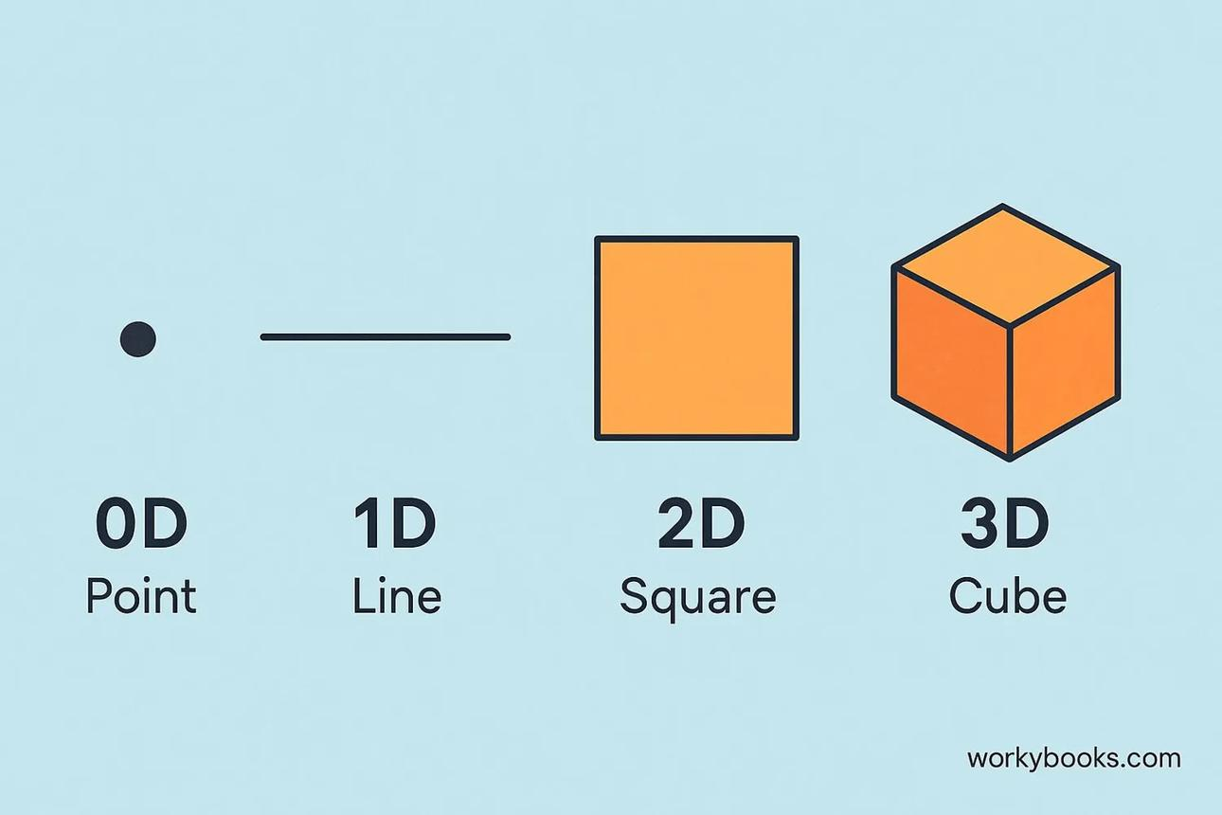
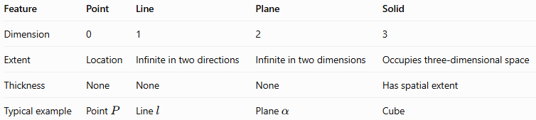
Feature | Point | Line | Plane | Solid
Dimension | 0 | 1 | 2 | 3
Extent | Location | Infinite in two directions | Infinite in two dimensions | Occupies three-dimensional space
Thickness | None | None | None | Has spatial extent
Typical example | Point $P$ | Line $l$ | Plane $α$ | Cube

Constructing Plane in Solid Geometry

Instruments Used
# Source: AI Source: Provided by: [Data Path: Persons Table -> ID Column: 1, Name_En Column: Motasem Essam] -> From: [ChatGPT] on [7/25/2026]
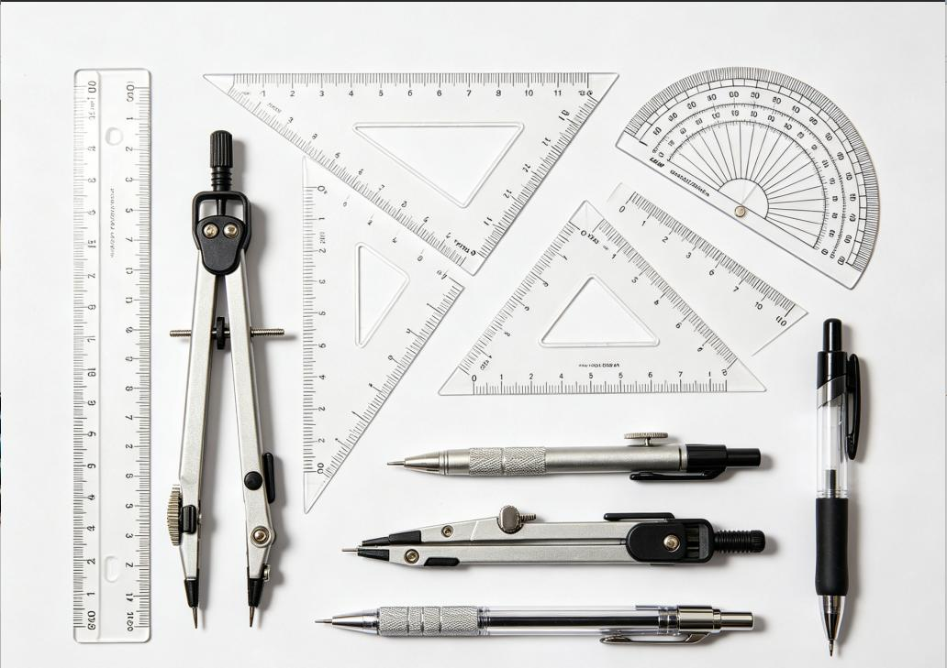
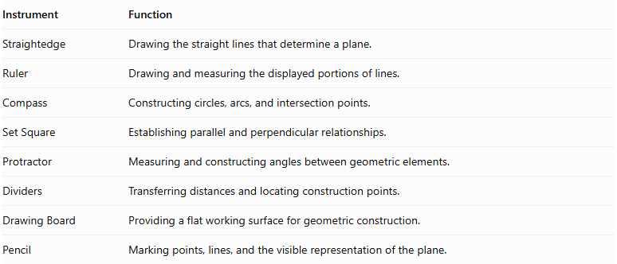
Instrument | Function
Straightedge | Drawing the straight lines that determine a plane.
Ruler | Drawing and measuring the displayed portions of lines.
Compass | Constructing circles, arcs, and intersection points.
Set Square | Establishing parallel and perpendicular relationships.
Protractor | Measuring and constructing angles between geometric elements.
Dividers | Transferring distances and locating construction points.
Drawing Board | Providing a flat working surface for geometric construction.
Pencil | Marking points, lines, and the visible representation of the plane.

Construction Procedures

Constructing a Plane Through Three Non-Collinear Points
# Source: AI Source: Provided by: [Data Path: Persons Table -> ID Column: 1, Name_En Column: Motasem Essam] -> From: [ChatGPT] on [7/25/2026]
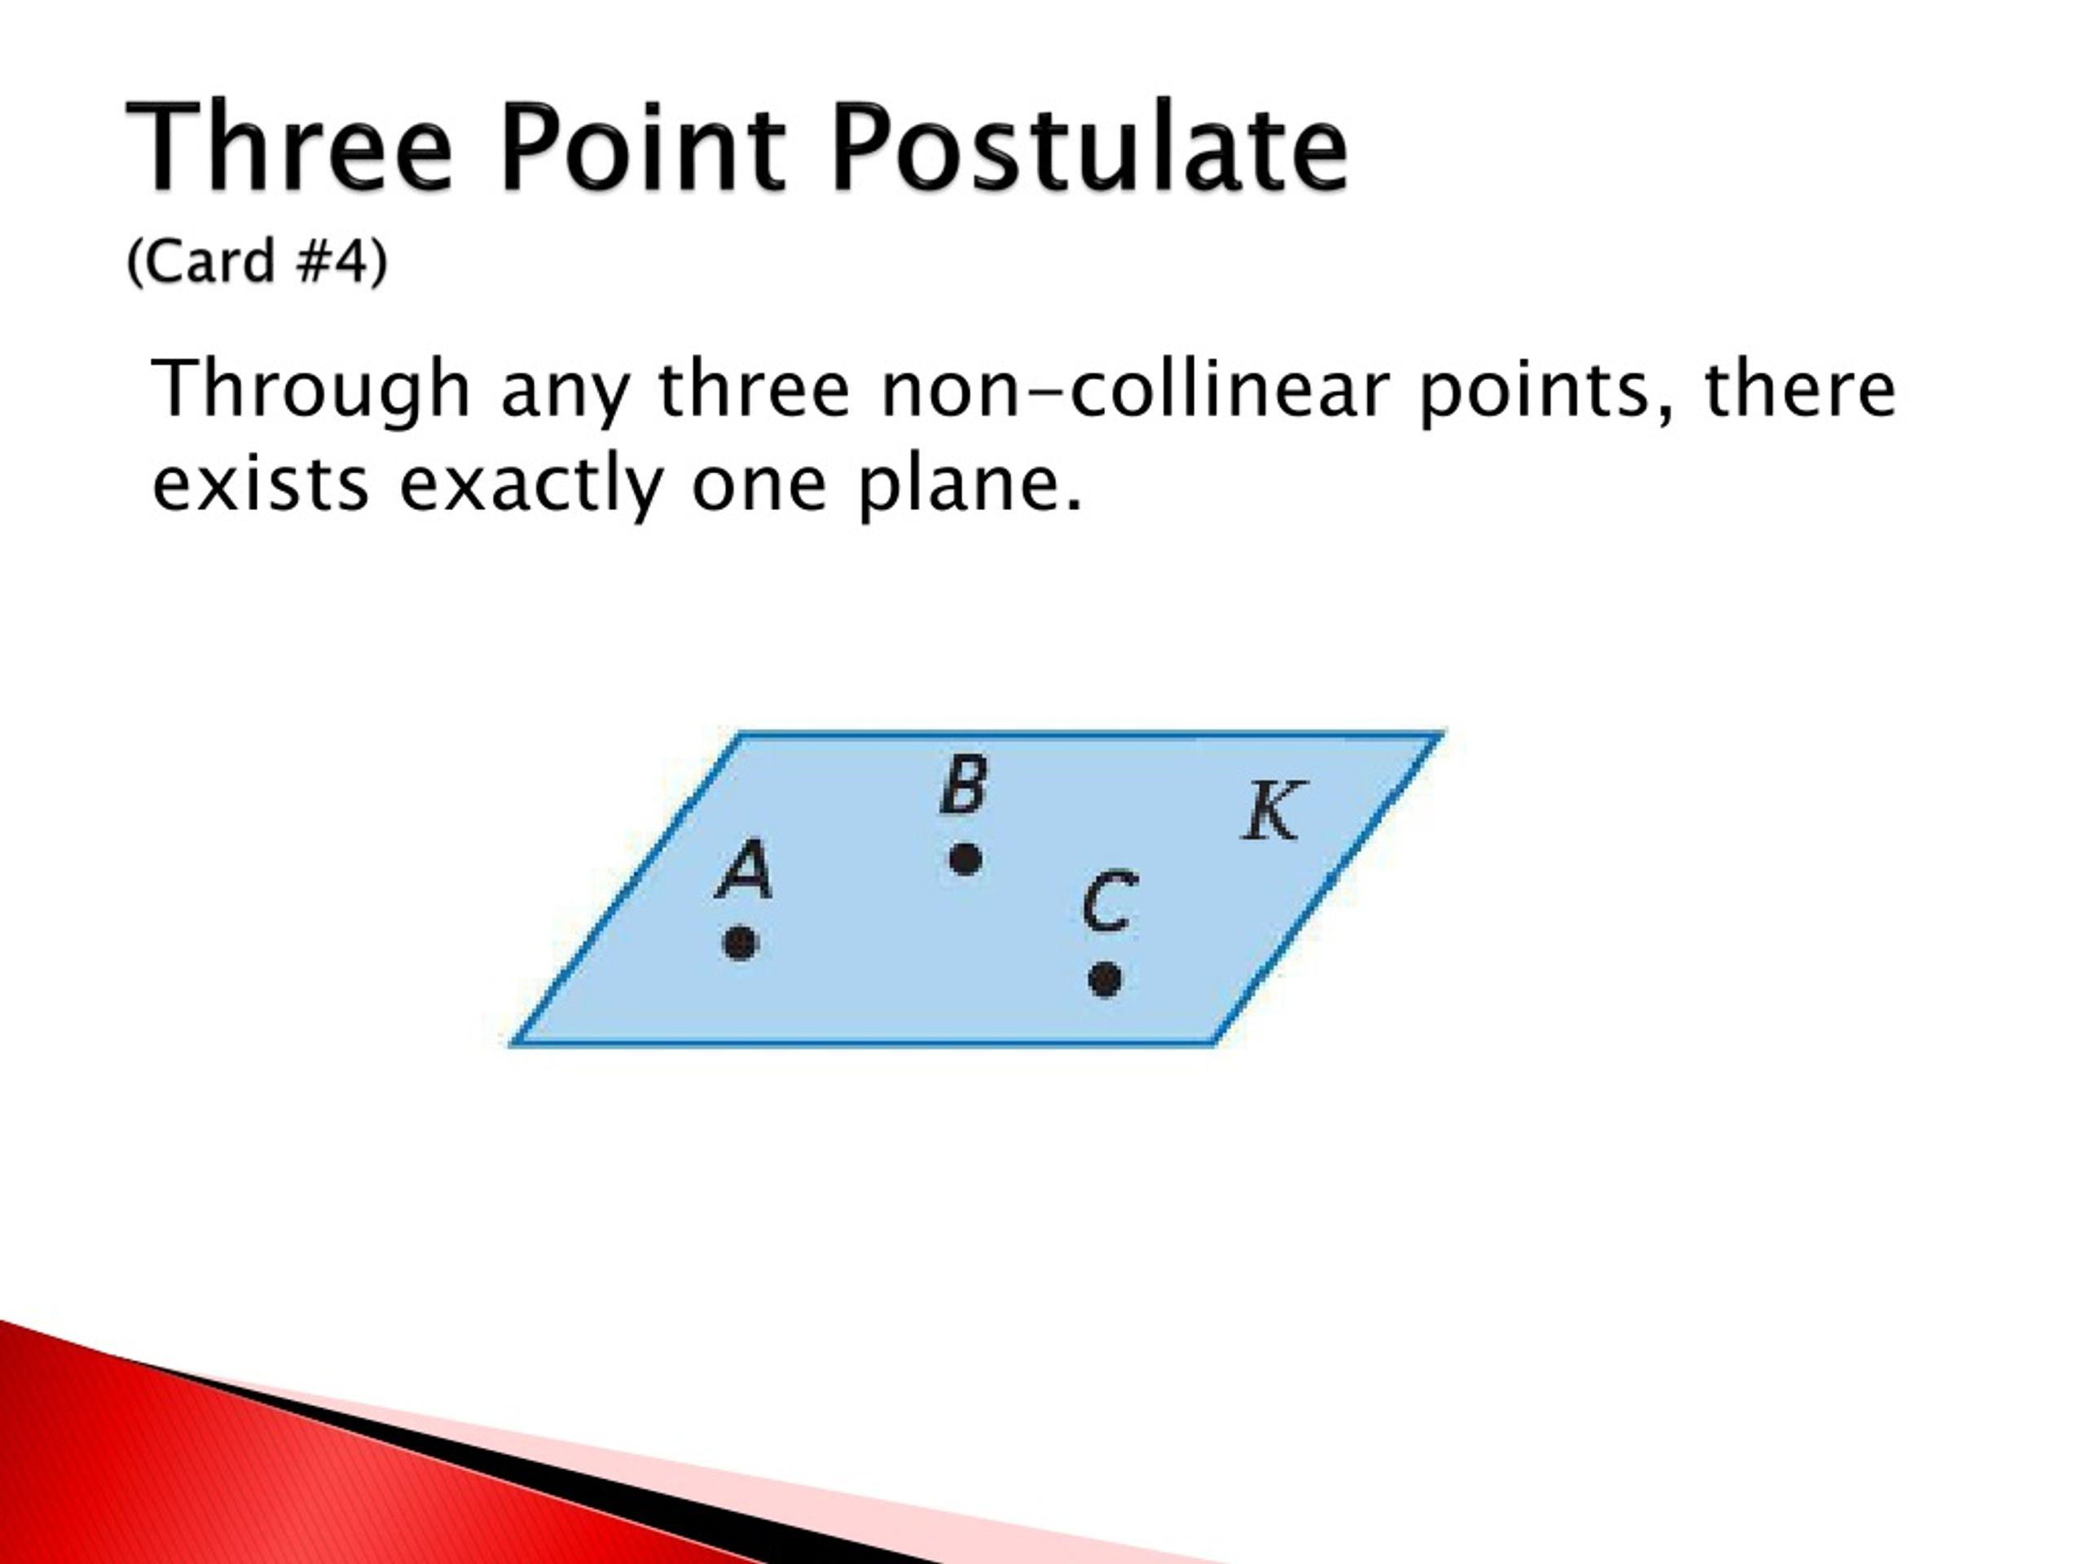
- Mark three distinct points $A$, $B$, and $C$.
- Ensure that the three points are not collinear.
- Use a straightedge to connect $A$ to $B$.
- Connect $B$ to $C$.
- Connect $C$ to $A$.
- Represent the plane using a parallelogram-like outline containing the three points.
- Label the plane $ABC$.
The three points determine exactly one plane.

Constructing a Plane Through a Line and an External Point
# Source: AI Source: Provided by: [Data Path: Persons Table -> ID Column: 1, Name_En Column: Motasem Essam] -> From: [ChatGPT] on [7/25/2026]
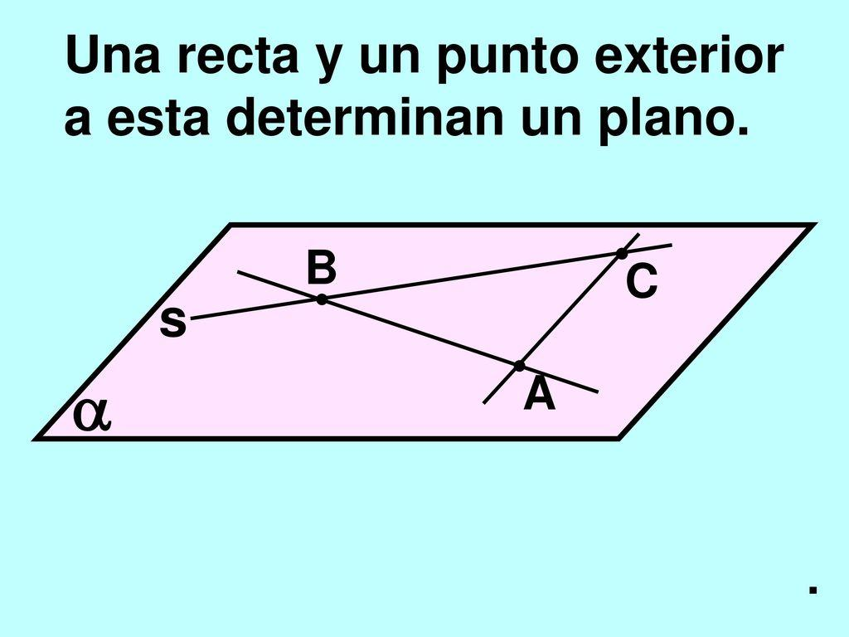
- Draw or identify the given line $AB$.
- Mark a point $C$ that does not lie on the line.
- Draw a connecting line from $A$ to $C$.
- Draw another connecting line from $B$ to $C$.
- Represent the plane containing both lines.
- Label the plane $ABC$.
The given line and external point determine exactly one plane.

Constructing a Plane Through Two Intersecting Lines
# Source: AI Source: Provided by: [Data Path: Persons Table -> ID Column: 1, Name_En Column: Motasem Essam] -> From: [ChatGPT] on [7/25/2026]
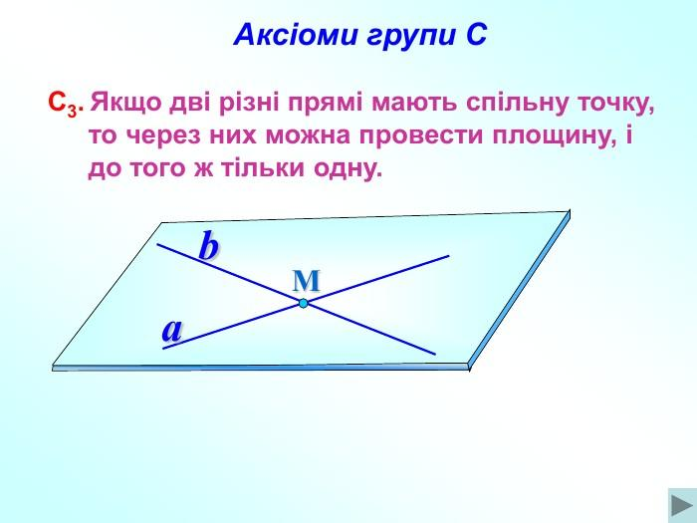
- Identify two distinct lines that intersect at point $P$.
- Mark the intersection point.
- Select another point on each line.
- Represent both lines within the same plane.
- Draw the visible plane outline around the lines.
- Label the resulting plane.
Two intersecting lines determine exactly one plane.

Constructing a Plane Through Two Parallel Lines
# Source: AI Source: Provided by: [Data Path: Persons Table -> ID Column: 1, Name_En Column: Motasem Essam] -> From: [ChatGPT] on [7/25/2026]
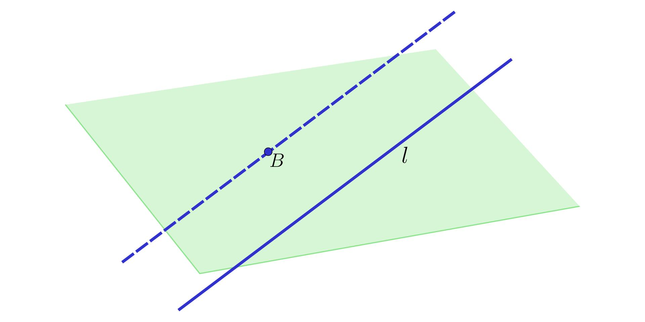
- Identify two distinct parallel lines.
- Select two points on the first line.
- Select a point on the second line.
- Represent the two lines within the same plane.
- Draw the visible plane outline.
- Label the resulting plane.
Two distinct parallel lines determine exactly one plane.

Constructing a Parallel Plane
# Source: AI Source: Provided by: [Data Path: Persons Table -> ID Column: 1, Name_En Column: Motasem Essam] -> From: [ChatGPT] on [7/25/2026]
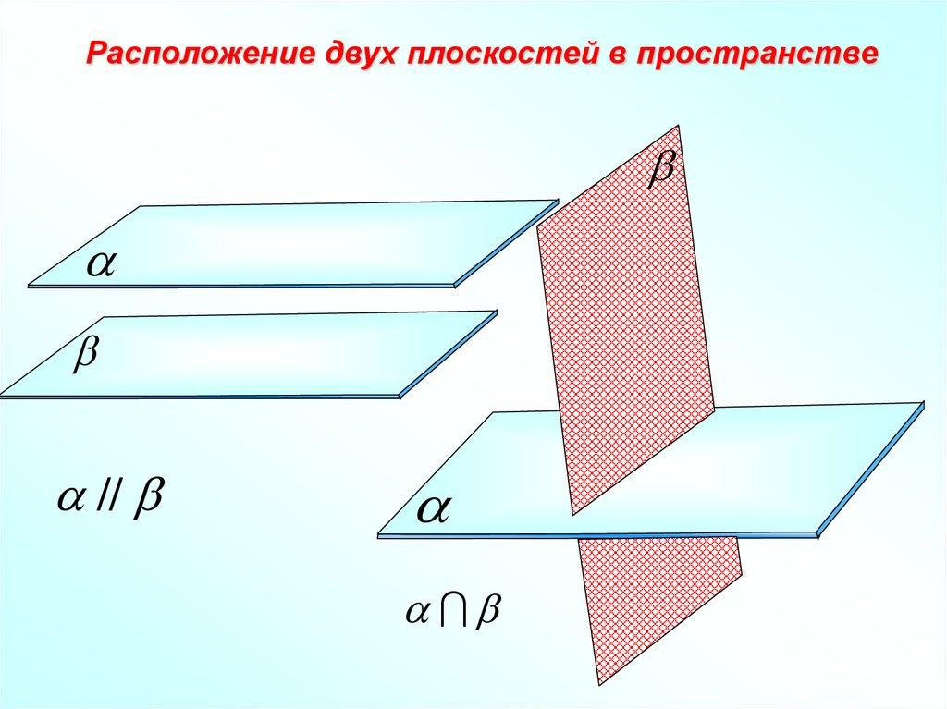
- Identify the reference plane.
- Determine the required position of the new plane.
- Establish two intersecting reference directions within the original plane.
- Construct corresponding parallel directions through the required position.
- Use those directions to determine the new plane.
- Represent both planes and indicate their parallel relationship.

Constructing a Plane Perpendicular to a Given Line
# Source: AI Source: Provided by: [Data Path: Persons Table -> ID Column: 1, Name_En Column: Motasem Essam] -> From: [ChatGPT] on [7/25/2026]
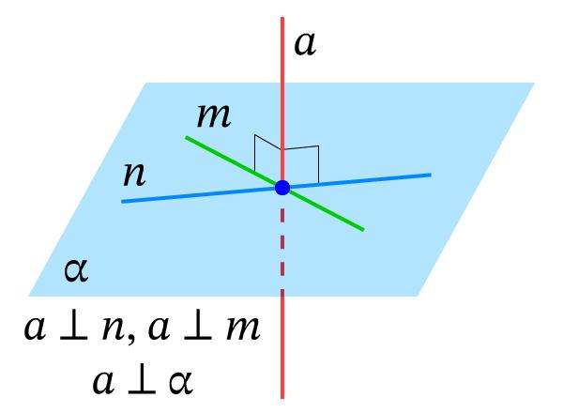
- Identify the given line.
- Determine the required point through which the plane must pass.
- Establish two distinct intersecting lines through that point, both perpendicular to the given line.
- Represent the two constructed lines within the same plane.
- Draw the plane containing them.
- Mark the right-angle relationship between the given line and the plane.
Important: A line is perpendicular to a plane when it is perpendicular to two intersecting lines in that plane passing through the point of intersection.

Constructing a Section Plane Through a Solid
# Source: AI Source: Provided by: [Data Path: Persons Table -> ID Column: 1, Name_En Column: Motasem Essam] -> From: [ChatGPT] on [7/25/2026]
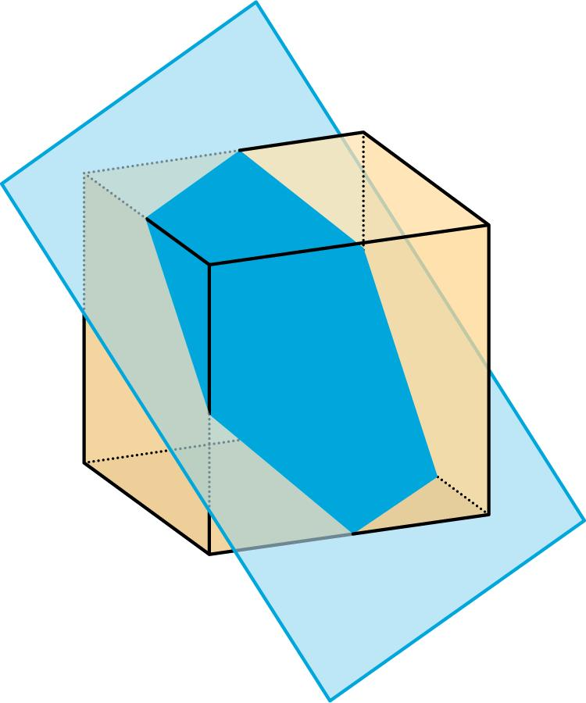
- Identify the solid to be intersected.
- Determine the required position and orientation of the section plane.
- Identify the points where the plane intersects the solid's edges or surfaces.
- Connect the relevant intersection points according to their positions on the solid.
- Draw the plane passing through those points.
- Identify and represent the resulting cross section.

Applications of Planes in Solid Geometry
# Source: AI Source: Provided by: [Data Path: Persons Table -> ID Column: 1, Name_En Column: Motasem Essam] -> From: [ChatGPT] on [7/25/2026]
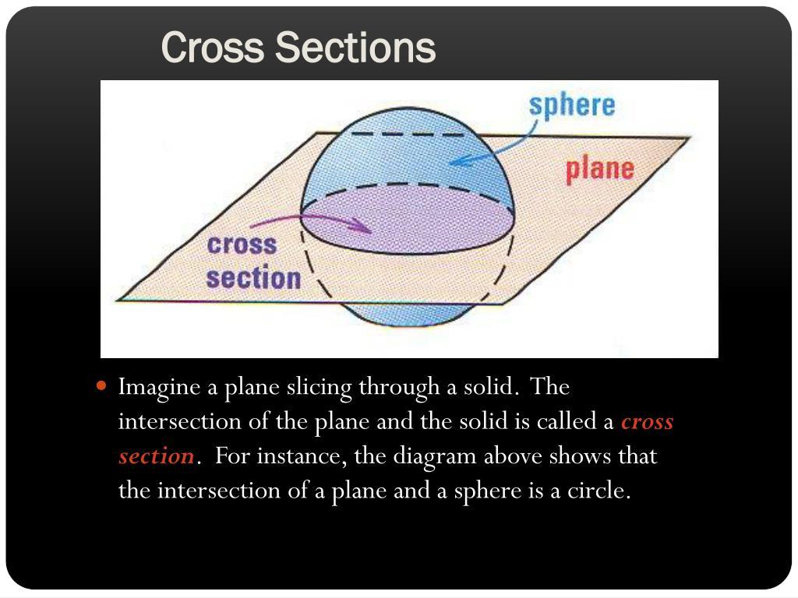
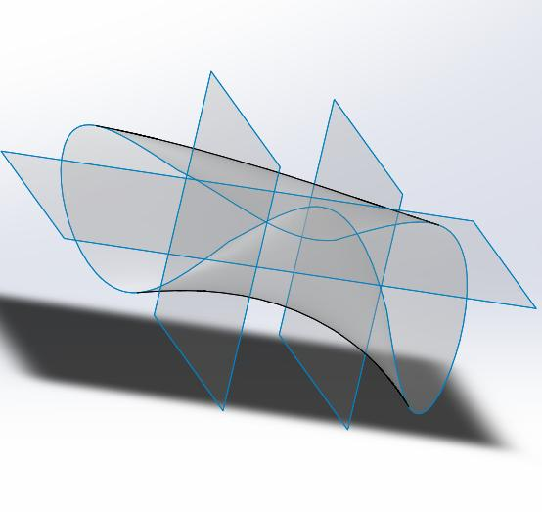
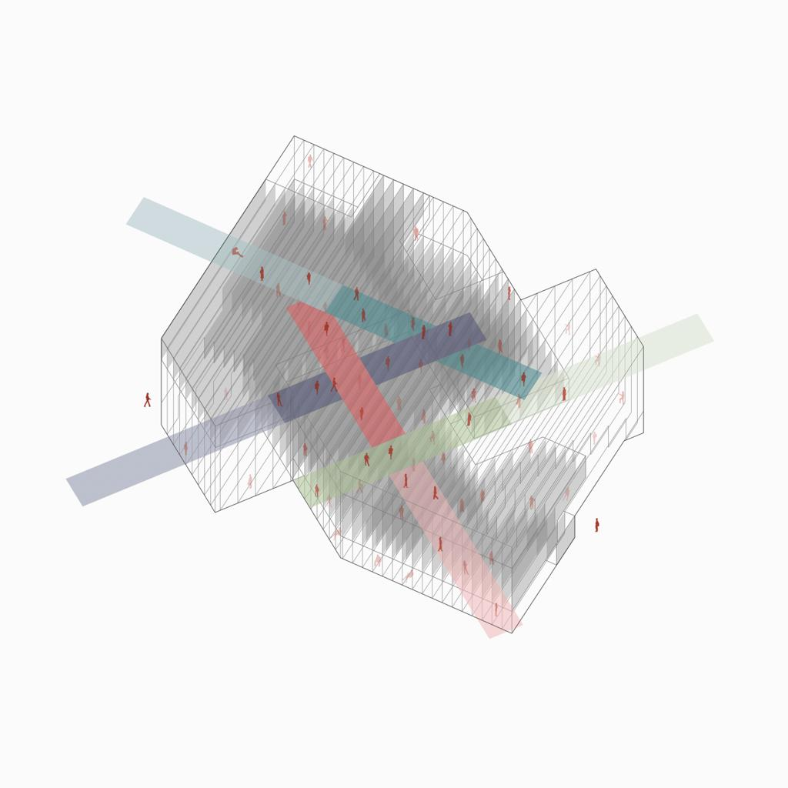
Planes are used in:
- Architecture: Representing walls, floors, ceilings, and structural surfaces.
- Engineering: Defining reference surfaces, component orientations, and design geometry.
- Computer Graphics: Modeling surfaces and calculating object intersections.
- Spatial Measurement: Finding angles and distances between geometric objects.
- Cross-Section Analysis: Studying the shapes formed when solids are sliced by planes.

Key Points
# Source: AI Source: Provided by: [Data Path: Persons Table -> ID Column: 1, Name_En Column: Motasem Essam] -> From: [ChatGPT] on [7/25/2026]
- A plane is a flat, two-dimensional geometric surface with no thickness.
- It extends infinitely in all directions within the plane.
- Three non-collinear points uniquely determine a plane.
- Two distinct planes either are parallel or intersect along a straight line.
- A plane can contain a line, intersect a line, or be parallel to a line.
- The equation $ax+by+cz=d$ represents a plane in three-dimensional Cartesian coordinates.

Conclusion
# Source: AI Source: Provided by: [Data Path: Persons Table -> ID Column: 1, Name_En Column: Motasem Essam] -> From: [ChatGPT] on [7/25/2026]
A Plane in Solid Geometry is a fundamental two-dimensional geometric object embedded in three-dimensional space. It provides a framework for studying points, lines, angles, parallelism, perpendicularity, and intersections between geometric objects.
Planes are essential for understanding the faces of solids, defining spatial relationships, representing surfaces mathematically, and analyzing cross-sections. They also form an important foundation for coordinate geometry, architecture, engineering, and three-dimensional modeling.

